

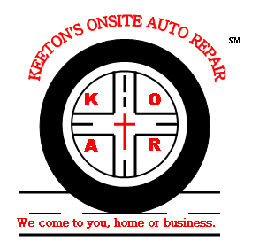


If you calculate what the cost may run you yearly, the difference may be a no brainer. Let’s talk about onsite auto repair perks.
- Mechanic comes to you vs. you save gas driving
- Help increase the longevity of your vehicle.
- Saves you tow & rental car fees
- You can wait in the comfort of your home or business
- Save on high shop fees and unnecessary repairs
What is the difference between an auto shop vs. onsite?
Preventive Maintenance for commercial and individual vehicles

.
Questions or comments? E-mail us at koarpm@yahoo.com
or call us at 972-298-3317
Why it is important to get preventive
maintenance on your vehicle?
View website for details at: www.keetonsonsiteautorepair.com
What to do before using an onsite auto repair business?
1. Here at Keeton’s Onsite Auto Repair, our customers are important to us.
2. We make sure you are aware of other vehicle recommendations needed.
3. We come to you, home or business.
4. We are located in the AT&T Yellow Pages
5. This is a business not a side job. We take pride in our work.
No More Towing Fees
The difference is in your savings.
Getting preventive maintenance on your vehicle(s) can save you a whole lot of money. For now let’s talk about why it is important to get it for your vehicle.
- Helps keep the longevity on your vehicle
- Save money on expensive repairs
- Helps alleviate stress from breakdowns
- Save money on tow & rental car fees
- Allows you to get the problem fixed before it gets costly
- Saves you time waiting until vehicle is repaired
- Helps your vehicle warranty to stay in tack

View website for details at: www.keetonsonsiteautorepair.com

